**PR**com

INDEX

INTRODUCTION 3

PART 1: IDEA & CONCEPTUALISATION 4

Idea initiation 4

Value proposition 5

PART 2: TARGETS & DEFINITION 7

Market segmentation and competition 7

Requirements of the SeniorAdopt app 11

Breaking down the work 14

PART 3: PLANNING & FINANCES 19

Business model 19

Project coordination 20

Timelines and workload 22

Financial requirements 24

Risk Management 26

PART 4: VISUALISATION & EXECUTION 32

Key functionalities of the SeniorAdopt app 32

Design and visuals 33

PART 5: THE FUTURE 46

Future development 46

REFERENCES 47

APPENDICES 50

## INTRODUCTION

Technology is a fast-developing tool in today’s society. Without it, the people who haven’t learnt it end up lagging behind with both social and standard living requirements. With banks, pharmacies, stores, and more, transitioning most of their services to mainly be operated online it can be overwhelming for the unexperienced user. At the same time, it creates a divide between the younger generations and the older ones. For this reason, we decided to develop an application by the name of SeniorAdopt.

The main use for the application would be to connect younger people, and seniors for the reason of helping the seniors understand technology, and for both generations to remove the divide to one another. Another part of the application would be to allow for the seniors to pay for simple physical tasks that one would generally have to do during a week. It would also allow students or teenagers to solve real problems and gain valuable and professional experience. SeniorAdopt is all about creating a true relationship between the Junior and the Senior, based on *Trust*, *Caring* and *Sharing*. The purpose of SeniorAdopt app is to allow every senior to ask for assistance to reliable students or teenagers, at any time, any place and for any kind of task or service.

## PART 1: IDEA & CONCEPTUALISATION

### Idea initiation

SeniorAdopt has been thought to solve a real problem worldwide: non-assistance to seniors. Indeed, many seniors in the world are suffering from loneliness that has many impacts on their healthcare, but also from lack of knowledge in technology, causing many issues to them every day.

1- Loneliness among elderly

Recent studies from *Centers of Disease Control and Prevention (CDC)* have shown that loneliness and social isolation are linked to health conditions, especially among elderly. A report from the *National Academies of Sciences, Engineering, and Medicine (NASEM)* pointed out that one-fourth of 65 years old and more people are considered as socially isolated (CDC, 2021). As a matter of fact, those studies found that:

* Social isolation significantly increased a person’s risk of premature death from all causes, a risk that may rival those of smoking, obesity, and physical inactivity.
* Social isolation was associated with about a 50% percent increased risk of dementia.
* Poor social relationships (characterized by social isolation or loneliness) were associated with a 29% increased risk of heart disease and a 32% increased risk of stroke.
* Loneliness was associated with higher rates of depression, anxiety, and suicide (ibid.)

2- Technology issues among elderly

The *Eurostat* has shown through statistics studies that 87 percent of people aged 75 years old and over have never been online (Eurostat, 2018). Therefore, it has been pointed out that seniors struggle a lot with reduced reactivity, explaining why they have hard issues using technologies. For instance, US statistics have shown that 23% of seniors have a physical or health condition that makes reading difficult or challenging (Smith, 2014).

On the other hand, the *Eurostat* has shown that the lack of knowledge about technology is one of the biggest issues for seniors. According to the *Pew Research Centre* in 2014, 77% of elderly reported that they would require assistance to learn how to use smartphone or tablet (No Isolation, n.d.).

From that information, we know that non-assistance to seniors is a real issue that is prevalent on a bigger scale in the world when it comes to health and technology knowledge. Therefore, we decided to create SeniorAdopt as a solution to this matter.

### Value proposition

SeniorAdopt is being built to create a real bridge between old and young generations. The purpose of the app is for students or teenagers to offer several kinds of services that would make life easier for seniors. This way, it would allow young generations to get valuable professional and human experience, contributing to reduce the number of old people suffering from loneliness, handicap, or lack of knowledge.

In order to cover all the issues that seniors could face, SeniorAdopt is proposing three different types of services: “*Social*”, “*Manual*” and “*Practical*”. First, the social services are specifically dedicated to creating a real connection between a junior and a senior who needs company. The kind of activities that could be proposed are talking, pet caring, shopping. Secondly, there are manual services are related to seniors having a handicap or disability to take care of their own wants or needs. The tasks proposed are mostly concerning gardening and householding. Finally, the practical services have been added to the application for seniors to keep stimulating their learning skills. Also, it allows young generations to share their experience and hobbies on many fields to teach the seniors about things such as computing and technologies, languages skills, cooking, drawing, etc. The app also offers a bank of additional tutorial videos related to the practical tasks.

Considering the potential issues for seniors when using smartphone apps properly, SeniorAdopt has been designed very minimalistic, intuitive and clear to offer the best user experience to its customers. This will be explained further in Part 5: *Visualisation & Execution*. In order to face the lack of connection between old people of the juniors (Cybulskis et al., 2013, p. 7), SeniorAdopt has established a real and professional hiring system to send the best applicants on the different services. Furthermore, the app offers a first free consultation with a junior in order to prevent any trust issue to occur.

Regarding the potential issues about confidence and first-aid for the juniors, SeniorAdopt has created different briefing and training sessions with professional that can be followed physically or remotely. Those sessions are optional and are accessible for juniors who need additional methods for teaching and practising.

On the other hand, SeniorAdopt has set up a three-day professional training course based on both theoretical and practical parts of first-aid issues. This aims to make the juniors able to know what to do and how to assist the seniors in case of any emergencies that could potentially occur.

SeniorAdopt is a powerful digital tool allowing seniors to call younger generations for assistance at any time, any place and for a great number of services. It also creates first real opportunities for juniors to gain valuable and professional experience, earn money, and solve real issues people are facing worldwide.

The final sketch describing the whole SeniorAdopt’s value proposition is attached to the *Appendices*.

## PART 2: TARGETS & DEFINITION

### Market segmentation and competition

In order to succeed as a new app in a market where there’s “an app for everything”, we’ll need to know who the users of SeniorAdopt are going to be. To get to know the go-to market, a market segmentation must be conducted in order to better reach the target users.

So, who are the users of SeniorAdopt?

As the app name suggest, *seniors* will be the primary userbase, which means we’ll target seniors past the age of **60**. The other userbase are the *juniors*, and the app and the service it provides on the Junior section will target younger people between the ages of **16** and **23**.

By targeting these two groups we have two groups which we want to help, in three different ways:

The seniors are targeted due to them having had a long life, and many seniors are now struggling with age related issues. (WHO, 2021) These issues can be something as simple as the decline of their motor skills, pain related issues, lagging behind with learning modern utilities which are being phased into the daily lives of everyone, and lastly the lack of connection in activities that’s often found between the seniors and the younger generation of people.

The juniors are targeted as they are still young and have experience with the modern utilities that are being phased into society as time progresses. They are also lesser impacted by the decline of motor skills and have more mobility of their body. Many younger people also have a hard time finding jobs (Eurostat, 2021) while others have a hard time managing jobs next to their studies. By developing an application that will allow the juniors to manage for themselves when they are available to take on a job to help a senior, this solves the problem of having to meet for a job at a specific time set by your superiors. Keeping this in mind, the junior can earn money while studying on the side at his own pace thanks to the app.

Another factor, is that the difficulties to find a job or be unable to manage a 9-to-5 job on top on studies, leads to lack of work experience, and the lack of work experience leads to career gaps on their resume, which could be a deal-breaker for future career opportunities during the job application selection process. The services the app offers will help the juniors build a professional resume, where they can not only show off the skills acquired while performing the jobs, but also get valuable and professional references from a former employer, namely the seniors who engaged with the junior.

Third and collectively, both user groups are in this way able to interact with people of a different generation and teach one another things that the other one would most likely not know of. Examples of this are the young people teaching the seniors about technology, and the seniors teaching lifelong lessons, or general things such as how to make a budget, and handle economy more efficiently. This should help both parts earn more of a connection towards the age groups, and hopefully aim towards a more collected society.

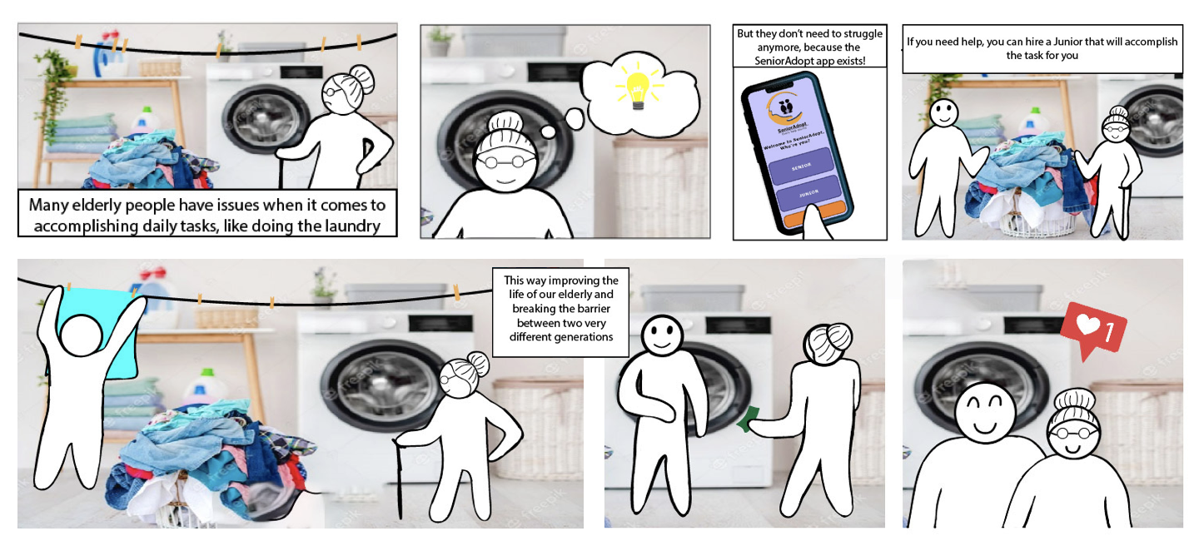

A storyboard depicting a situation where the SeniorAdopt app comes in handy.

Now that we have established who the users of the SeniorAdopt app most likely are, let's have a look at the best way to reach the target groups in order to market the SeniorAdopt app to them.

In order to target the users in the best possible way, we have a selection of user profiles that include seniors and juniors, but of somewhat different origins and interests. The user profiles are intended to create an impression of SeniorAdopt's users. These user profiles, or customer profiles, are called *personas*. The purpose of personas is to represent different users who may use SeniorAdopt, so that we can better understand their experiences, behaviour, goals, and needs in order to create, and continue to improve, the best possible user experience of the SeniorAdopt app.

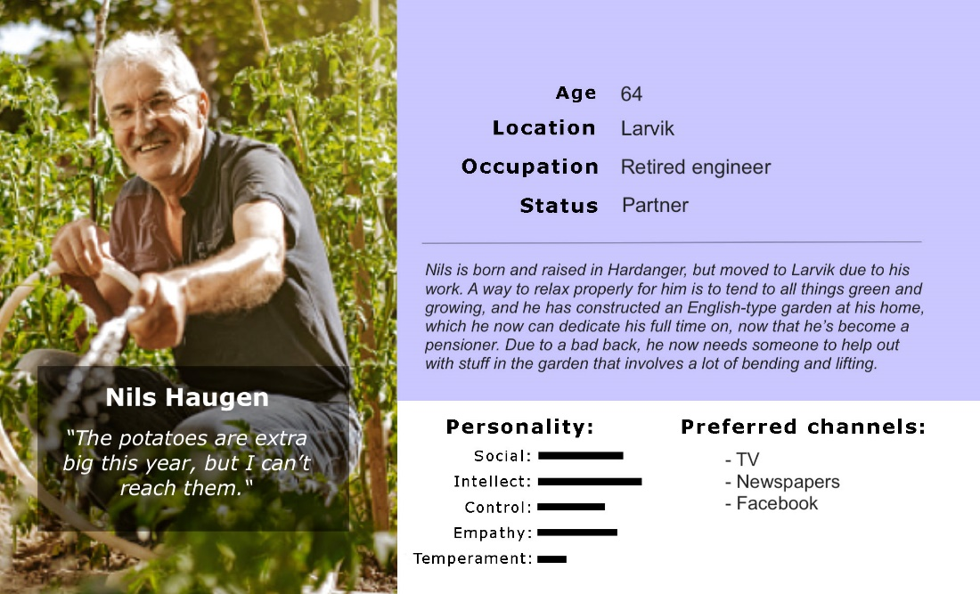

The persona Nils is based on users who’ve just entered retirement and is enjoying their new life. (Photo taken from Unsplash)

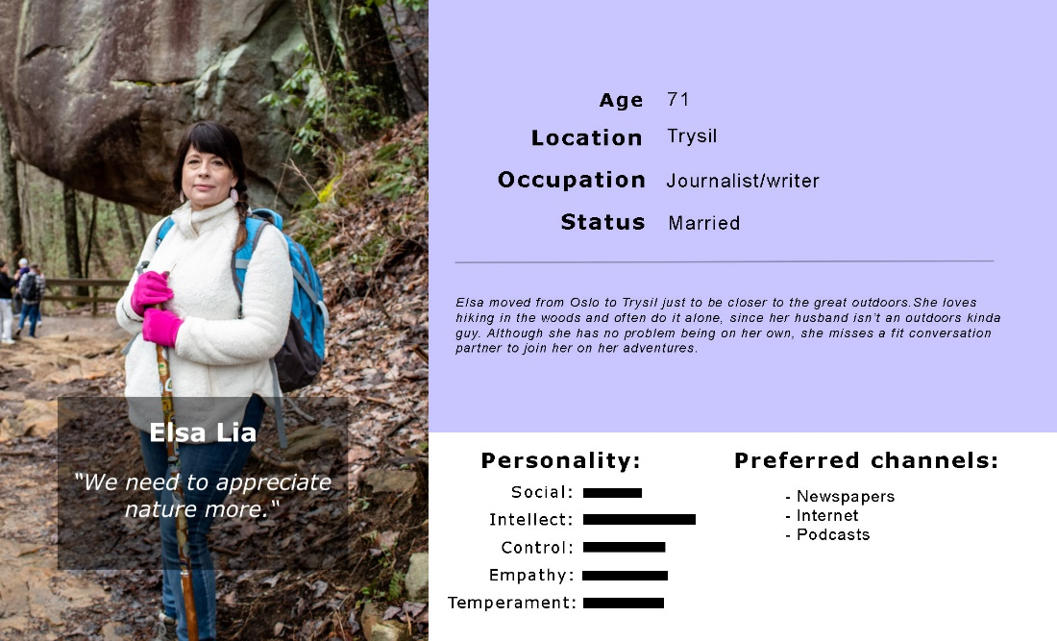

The persona Elsa is created to imagine senior users who are adventurous and open to new ideas. (Photo taken from Unsplash)

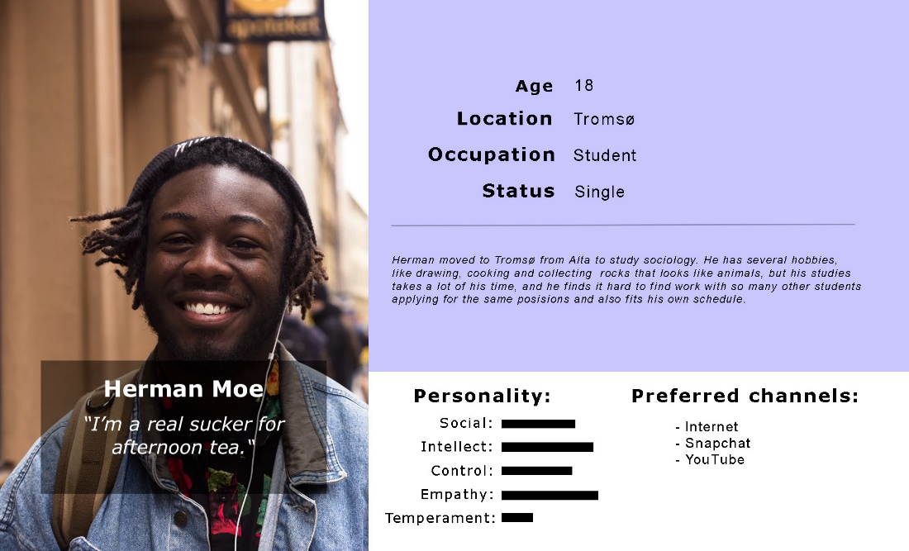

The personas Herman was made to give an idea of a possible junior user of SeniorAdopt. (Photo taken from Unsplash)

As we can see, many of the senior users are more traditional when it comes to preferred media, and it would be recommended to budget the marketing towards medias such as television, radio, and newspapers. However, the numbers of seniors using the internet on a regular basis is increasing yearly, making it advisable to market on platforms like Facebook and YouTube (Yeung, 2019). To market mostly on social media will be recommended for the younger users, with platforms such as Instagram, Snapchat, TikTok, and Facebook. There should be a budget post for online advertising with Google Ads to increase SeniorAdopt’s digital presence which will allow both target groups to be reached when they use specific keywords, such as “job”, “work”, “gardening”, “help needed”, and so forth.

We also have to recognise competitive apps which offer similar services, like OBOs *Nabohjelp*, *WeCare,* and *SeniorSmart*, but SeniorAdopt is unique from the fact that the app will create a bridge between senior and younger generations by creating work for the younger generation while helping the senior generation. SeniorAdopt will also be a unique gateway for seniors who struggle to keep up with new technology but are eager to learn.

### Requirements of the SeniorAdopt app

The functional and non-functional requirements of an app is often the question of “how” and “what”, with the functional requirements dealing with which requirements an app *should* have to function, and the non-functional requirements dealing with what requirements the app *must* have to function. For the SeniorAdopt app we acknowledge the need for the app to as simplistic and easy-to-use as possible, making the *user interface* (UI) and *user experience* (UX) high priority.

|  |  |  |  |
| --- | --- | --- | --- |
| **App requirements** | **Product & Services** | **Gain Creators** | **Pain Relievers** |
| Easy  UI/UX design | Two button designs, with forward/backwards interaction. | Since the UI/UX is simple, there is minimal interaction from the users to use the app | The users are able to easily navigate the application without requiring help from others. |
| Easy login | -Username  + password.  -E-mail  + password. | The users have a profile that they can visit and get reviews on their trust. | With the profiles they can see if the person is one, they would like to help them or help. |
| No ads or other distractions | Paid services (at least for some of the services offered) | Allows for more fluent app use, without tapping an ad and being pulled out of the app. | Avoids ads interfering with the trust for the app. Easier to use for the seniors with less distractions. |
| Verified user accounts | Encrypted, or scam preventing | By the users being verified it can show that they have been checked up on by the developers of the app | The customers can trust the people that are helping/helped |
| Safe and easy economic transactions | Encrypted, or via (external) online bank | The users will be able to use their bank accounts, and bank ID. Which is trusted and allow for secure transactions. | The bank will be the bank of the user, and will be familiar to use for ease |

The objective is to build an app with the purpose of giving seniors more confidence in technology despite not being a tech expert. However, we must also be aware of the problem which may occur when using the app. Therefore, it’s important to identify the issues and deal with them, understanding how we can prevent this and how to solve them when they happen.

Here is how we solve the issues:

1. Avoid unnecessarily irrelevant content, like ads and pop-up windows. The content should be focusing on what the user should be expecting when they login to the app.
2. Minimalistic design. Both UI and UX should be intuitive and based on what “everyone” is used to.
3. Consists of a clear and easy to follow instructions, like step-by-step on how to use the app; how to register, how to get started, and so forth.

The UI and UX design of SeniorAdopt is explained further in Part 5: *Visualisation & Execution*.

The table underneath is where we list out the scope of SeniorAdopt, as well as what is out of scope, in order to offer a better understanding what is to be expected of the app to our stakeholders.

|  |  |
| --- | --- |
| **In scope** | **Out of scope** |
| Geographical area: Norway. | Rest of the world. |
| Operating systems (OS): IOS and Android. | Windows and MacOS. |
| Payment solution: Paid services (fee/hour). | Ads. |
| Secure logins and verified accounts. | Guest users/anonymity. |
| **Social services:**  -Company/Conversation.  -Pet caring.  -Shopping together. | **Social services:**  -Medical personnel, like psychotherapist, nurse, etc.  -Veterinarian personnel.  -Personal shopper (the junior is going to *help* with the shopping, not doing the shopping itself). |
| **Manual services:** -Gardening, householding | **Manual services:**  -Hard labour |
| **Practical services:**  -Technology  -Teaching: cooking, drawing, Facebook/social media, etc. | **Practical services:**  -Technicians  -People with professional background |

For example: As of now, the main target area will be Norway, but that doesn’t mean the rest of the world is off-limits; it just means that the market/geographic area will always have the possibility to be expanded in future versions of the app.

### Breaking down the work

TheWork Breakdown Structure (WBS) is a document that breaks down the scope or deliverables of the project into individual work packages, including those related to the project management itself. In this way, each level shows the work packages that are part of the higher-level package.

Simple WBS with 3 levels

The first level we have defined is one with the project ideas and planning, I.E. SeniorAdopt. This level is the result of the final project, is reached after all the previous levels have been completed.

Moving to the second level, we start talking about the requirements of the project and the interfaces to be used. On the one hand, we have three interfaces which define the profile of different users; junior, senior and general*.* On the other hand, we have the requirements needed to create the application, which would be support, graphics, accessibility, infrastructure and analysis.

Detailed version with 4 levels of WBS

Let’s start analysing the senior interface and its sublevels. Within this interface we have the *payment system*, where we can see the payments that have been made (payments) or the ones that are pending (unpaid).

We also have the *booking system*,here we can see the following sublevels: *Category list*, where the senior can choose between the different category services. *Job request*, the option choose from all available services. After the seniors chooses the services they want, they will have a large list with all the juniors that are available for that task, this list is called applicant list, they will also have an option to choose between their favourites, I.e., people they had working for them before, and they want to come back once more.

After choosing the service you want and the person you want to work with, the junior has to contact the senior. For contacting, we have created the *contact system* functionality.This system goes on to notify the user via an automatic message and then calls them. After the point of contact, an appointment is scheduled between the senior and the junior.

We also have the *profile page* which is the description of each senior, their *reviews* and their *notifications*, for example to see if they have received a call or a message.

Thejunior interface:its sublevels are very similar to those of the senior. First, we create the application, where the junior must upload specific documents in order to register and be accepted. The reasoning for this is that SeniorAdopt has certain requirements before applying. Juniors must have ajob interview with recruiters, upload theirCV and accredit a course or do a CPR course to get medical training incase of emergencies with the seniors.

Once connected to the app, they have access to the *booking system*with different job offers where they can apply for the job and contact the senior. There is also a *profile page*, where the junior can put a description of himself, a video presentation to describe himself, another window to put the *reviews* of the previous works he has done and a last window for notifications. This profile page will also be very useful for the seniors in order to review the junior they will ask to complete their task and prevent any trust issue to occur.

Finally, SeniorAdopt has designed the general interface, which consists of two sub-levels: *login* and *registration*. Within the login we have everything that is required to access the account, you will have to log in with an account (email) that has already been created previously and write the password to be able to enter the account. After entering the data in these two fields, there will be a button to access the account and a login button.   
At the registration level, an account must be created with all the data of the new user. There will be 9 fields to fill in, as follows:

*Name*, *Surname*, *Date of birth*, an *email address* with which you have not registered before, a password, gender, home address, postcode, phone number, and a last field to upload all the necessary documents. All these fields must be filled in, as the app system will not let you create the account unless all the requirements are completed.

Another important factor in the second level is accessibility, where a browser will be created for the user. Thanks to this browser, the user will be able to have amenu, buttons to go forward or redo and to log out.

We also have theinfrastructure, where this can be differentiated into two sections. Hardware and software. Within the hardware we will have our own servers and telephones. Where the data of our users will be stored.

We will use basic editor software, which consist of using certain apps to create the app, modify it or update it. The ones we use because we find them the most convenient are *Adobe, Microsoft Office,* or *Visual Studio Code*.

And outside the basic ones, we have *databases* and *security.* Here we will have to create the app with a very secure base, otherwise we can have many problems, which are analysed and explained in the risk management section. It is also necessary to have a database to store all the data of all SeniorAdopt users.

And finally, we have the*analysis level*, where the whole application will be analysed in different ways, such ashigh-level analysis, a detailed analysis of the core modules, and a final analysis of supporting modules.

Something we must keep in mind is that the WBS is a dynamic part, i.e., it is not stable, and the same throughout the project. For example, when you change something in the CPM, this implies a change in the WBS as well. The change depends on its importance, because if for example a new requirement or interface is added, this means that it would have to be changed at level 2.

These are some of the changes we have had to make to the WBS as the project progressed:

* We realised when we finalised the CPM that it was necessary to add an analysis requirement at the second level.
* We also had to add an accessibility section of its own, since this is going to be a major consideration to the UI and UX.

On the other hand, we had to make some changes when we finished the CPM and checked if everything was in place. We realised that some options had to be repositioned and moved from their sublevels.

## PART 3: PLANNING & FINANCES

### Business model

The Business model of SeniorAdopt is composed of two main sources: price commissions on each junior assistance and partnership revenue.

Concerning the price of junior assistances, only manual and practical services are invoiced by a fee per hour going from **180NOK** to **250NOK**, depending on what kind of service is provided from the three categories explained in *Value Proposition* (*“Social”*, *“Manual”*, and *“Practical”*) on page 5.

The price commissions of SeniorAdopt will always be **25%**.

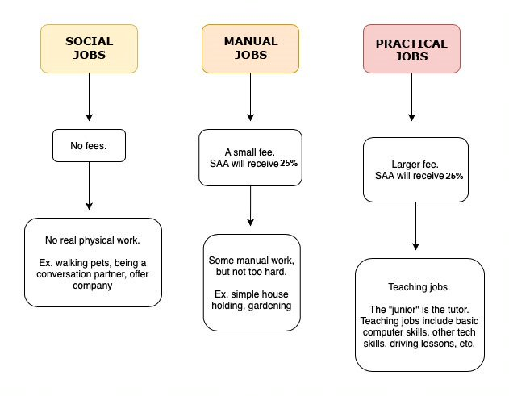

Image describing the different services proposed by SeniorAdopt.

On the other hand, many partnerships will be established with SeniorAdopt in order to gather more and more accessible activities for seniors and create several communities. Therefore, it will mostly concern partners as private activities centres for seniors, cinemas, theatres.

Why would it be interesting for the seniors?

These partnerships would allow them to do all kinds of activities getting special offers. For example, there would be a possibility for seniors to watch old movies or shows for a very low price through the *senior cinema theatre offer*. They could also get a “senior pass” at a decent price for each month. The cinema company *NF Kino* owns cinemas in 15 Norwegian cities and offers this on all their cinemas (NFKino, n.d.).

Finally, they could join sport activities centres and get private lessons with professionals for a reasonable subscription price per month as well as a discount on group workout sessions for seniors. With all the different gym centres around Norway there will be many potential partnerships to be made.

### Project coordination

The program evaluation review technique (PERT) is a plan to estimate the data that will be introduced to the critical path method (CPM) described later on. It will allow for ease when writing the CPM, as you have already designed the structure of it and are now visualizing it in a more design efficient way.

The PERT starts its structure from the work breakdown structure at level 2 and moves onto level 3. From there it’s described which work package is to be completed. It describes the duration in the most optimal cases, the most likely duration and the duration in a worst-case scenario. The resources for each individual task are listed, and the amount of estimated efficient workhours. The workhours in one day are then estimated, as well as the hours in a week and weeks. The first stage of the PERT is finished off with the total work time in hours, days, and weeks

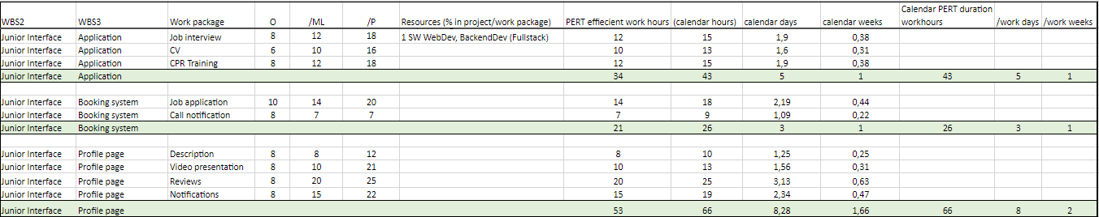

Image displaying a portion of the PERT table.

The critical path method (CPM) is developed as a basic version of the timeline, and to display what parts in the timeline is more critical than other parts. The critical part of the CPM is the part without margin were if it gets delayed the whole project gets delayed. We split the project into different paths, where the path that takes the longest time to complete will be the critical path. This is due to without it being completed, work on the other paths cannot be commenced. The other paths will not be critical and will have margin to be completed at a later stage, as long as they are all ready for the merging with the critical path, and the non-critical paths. This means if the path with margin gets delayed it won't affect the whole project unless the delay is longer then the margin of the critical path.

We use the data from the PERT chart each of the CPM activities gets its own box within the CPM chart. The boxes get placed in order from what the PERT chart defined. In our case we decided to not write what order the different boxes were going to be placed in, inside of the PERT and instead experiment and discuss while doing the CPM layout on a blackboard. We did this find out the order and the different paths.

After a few times working on the blackboard, we were happy with the layout, we converted it into a digital format and put in the numbers we had decided upon. Now we were able to see, and distinguish which paths were critical and which paths were not, with visual paths.

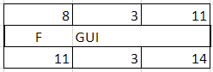

The box shows the amount of time it will take, what’s the earliest and latest start and end. From that we calculate the margin.

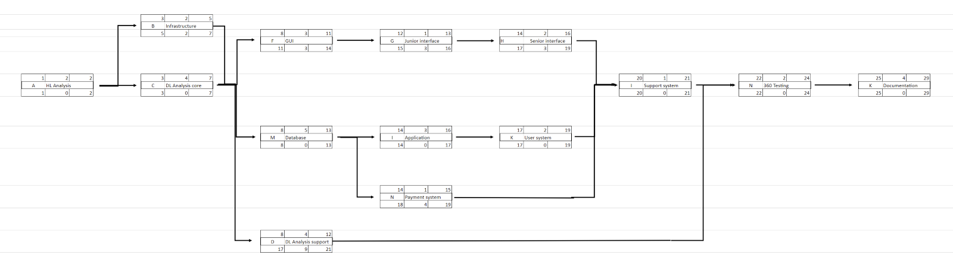

The CPM allows for the project management team to see the workflow of the entire project. For us it became clearer after the CPM on what the basic timeline would look at and what parts would be more important.

### Timelines and workload

The Gantt chart is a detailed timeline of the project which includes the title of the task, the owner of the task, and the dates from start to finish with the duration of each development stage. It shows how far each stage has come along and includes a visual representation of the task duration. The tasks are distributed into levels, that refer to the work breakdown structure which shows what deliverables are required for the app to function and be developed fully.

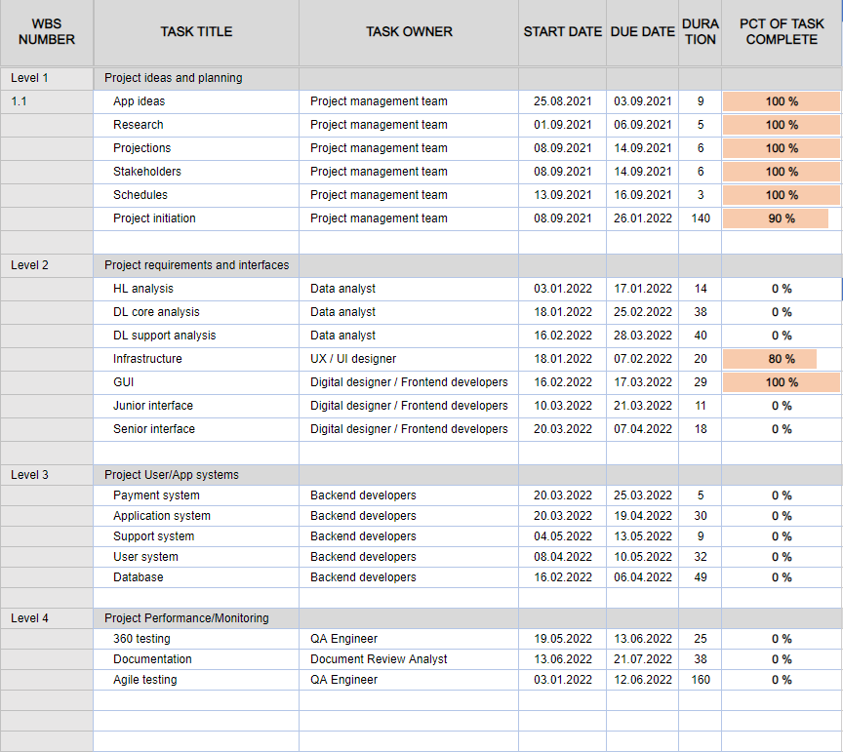

Image representing the first section on the Gantt.

The different tasks to build SeniorAdopt app have been split in 4 respective levels: “Project ideas and planning”, “Project requirements and interfaces”, “Project User/App systems” and “Project Performance/Monitoring”. The whole project has been scheduled to begin on January 3rd, 2022, and end on July 21st, 2022.

The first level, Project ideas and planning, is related to all pre-made work about ideas, research and projections that have been used and established to build the app. This part of the project lasted three weeks.

The second level, Project requirements and interfaces, is dedicated to the beginning of the app development itself. This part of the project will start on January 3rd, 2022, and end on April 7th, 2022. First, the different analyses of the project requirements will be made by our data analysts. Then, the app development of the interfaces will start. The general infrastructure of the app will be established by our UI/UX designers. The general interface, the junior interface and the senior interface will be designed by our front-end developers and digital designers.

The third level, Project User/App systems, is the one dedicated to the back end and databases part of the app development. This part of the project will start on March 20th, 2022, and end on May 13th, 2022. Every system part of the project generating databases will be conducted by our back-end developers.

The fourth level, Project Performance/Monitoring, is focused on testing and the maintenance of the app development. This part of the project will start in the beginning of the App development on January 3rd. 2022 and will end on July 21st, 2022. The agile testing will continue through the project's development, being done once at the end of each week. The 360-testing for the final app version, will be conducted by our QA engineers. The final step is the whole documentation of the app will be checked by our Document Review Analyst.

### Financial requirements

The financial budget of the project management consists of the economic data of the entire project and requires insight on the financial salaries of each individual occupation, and how to finance the different resources needed for the development.

Other than manpower, there is a plentiful budget consisting of licences, servers, workstations, office space, and miscellaneous equipment. Lastly and probably most importantly the marketing which will allow for exposure and reputation between users who will allow us to regain financial stability once the app is funded and developed.

The financial estimate of the budget not only requires extensive research on the salaries of the occupations and the wages of each country where one will hire workers from. Each country has different wages, and if the ones hired will work in the country they are living in, the wages must be in accordance with said country. This is also relevant in cases where the hired personnel will travel and work in a different country together with the others. In this case they will all be paid the salaries of the country they reside in while working.

The budget has been developed to refer to the eventual pay over a period of one year, with a summary of five years. It includes the listing of how many workers, and how which occupations are needed for the project to be completed. The salaries for the workdays in each month are listed and summarized to give a close estimate of the total cost for each paid worker.

In the budget, there is also included a buffer. The buffer is 20% during the development, and 5% during the operational upkeep. The buffer is there as a financial backup if the costs exceed the estimated value. With the buffer available the costs should be within the budget’s limitation, and there should be money leftover in the end in the case the budget is financially correct. This means the buffer could be used for future development cost instead.

The budget also shows the financial costs of the royalties, which are the cost of using someone’s platform to distribute our application.

Lastly, the budget includes the income. This includes how much we will profit from distributing and keeping the application operational, as well as how much the investors will earn back from investing in the project over a set amount of time.

What about the funding then?

Funding of the project is how we will finance the cost of the budget through such things as partnerships. The project management will need to reach out to those who could have an interest in helping senior people, and younger people. These could be senior clubs or youth clubs as these are both focused on the wellbeing of the targeted group. The senior clubs could be interested in the project due to allowing the seniors social interactions.

For the youth clubs its much of the same, where the social aspects are being handled through the interactions between the senior and the youth. This also fulfils the activity aspects which each of these kinds of clubs have.

Another sponsorship that would be viable is the *salvation army* which offers seniors activities, meeting grounds, adult day-care centres and residences. This makes them a perfect sponsor for our application

It is also possible to request state organized funding services, through websites such as altinn.no, which allows you to find funding services. (Altinn, n.d.)

One of those are *Norsk katapult* (Norsk katapult, n.d). which is a Norwegian programme which supports small and medium sized enterprises in Norway. They assist companies with equipment, facilities, developing prototypes, testing, visualization and simulation.

Another one is a start-up loan. This loan is only available once you have been registered in the *Central Coordinating Register for Legal Entities* (Om Enhetsregisteret - Brønnøysundregistrene. 2020)(CCR). as a joint-stock company. So long as the business has an exponential potential, and the possibility of succeeding on a global scale in the future. It's also important to have a budget and spending plan ready for future development and requirements to realize the plans in mind.

One way for a start-up to get funded is through personal investment (U.S. Small Business Administration, n.d), which is commonly referred to as bootstrapping where you try to rely on money not from outside investments (Kenton, 2003).

### Risk Management

Risk management is the part where we estimate the risk of different things that could happen. To identify the risks, we can look back at some of the other documents, simulate different scenarios, identify the risks that may come up and analyse them in order to find a way of avoiding it and a countermeasure in case it does happen during development. Some risks can be considered general, because a chance of occurrence exists in the development of any app. An example of such a risk would be data corruption.

After identifying all the possible risks, we need to analyse and rank them according to possibility of occurrence and level of impact for the development process. This is to see where to focus our efforts and energy. Since there wouldn’t be much of a point in deep analysing a risk that would have a scarce probability of happening and small impact, that time should be spent on working on a more dangerous risk.

Then we prioritise the risks.

We measure the effect it would have on the project in accordance with time, cost and quality. As an example, we can look at data destruction. If a programmer's drive failed, everything on that drive would then be lost. All that was on that drive would then have to be recreated. This would cost a lot of time, money or quality, depending on what has been lost. If they were creating the notification system, we could either recreate it, which would cost time and money, or drop the feature altogether, which would result in a lower quality of the app.

After the mitigation is implemented, when the drive would fail, the programmer can get a new drive and retrieve the data from the most recent backup. This would cost a small amount of money for the drive and very little time.

Before mitigation:

|  |  |  |  |  |  |  |
| --- | --- | --- | --- | --- | --- | --- |
| Data gets destroyed,  disappear, or get corrupted. | Private data and company files might be stolen or lost. This will cost a lot of **TIME**, **MONEY** and **QUALITY**. | 5 | 3 | 15 | Have a good backup system with multiple backups, use of git, and backup regularly. | IT Operations Manager |

After mitigation:

|  |  |  |  |  |
| --- | --- | --- | --- | --- |
| Data gets destroyed,  disappear, or get corrupted. | The files are quickly recovered from a backup, if possible, now it will cost little **time**, and maybe a small amount of **money**. | 2 | 2 | 4 |

Another example of a high-priority risk would be a poorly designed project purpose. Although the probability of occurrence is quite low, the impact on the project would be extremely high. Such lack of organization could easily lead to confusion regarding the tasks at hand, which could further lead to delays in the development process or final results that are not up to the standard we set out to reach.

|  |  |  |  |  |  |  |
| --- | --- | --- | --- | --- | --- | --- |
| Project purpose and needs are not well defined | Can cause confusion regarding the tasks that need to be completed, can result in delays or an unsatisfactory product | 5 | 3 | 15 | Define from the beginning the purpose of the project and complete a business case.  In case it occurs, rewrite a clear business case and submit it to the project board for approval | Project Manager |

The best way to eliminate this risk is by avoiding it altogether. Ever since the beginning of the development process, the management team should clearly define the purpose of the project and complete a well-defined business case. This way, the probability level would drop to a minimum and we can further focus our efforts on other high-priority risks.

|  |  |  |  |  |
| --- | --- | --- | --- | --- |
| Project purpose and needs are not well defined | Can cause confusion regarding the tasks that need to be completed, can result in delays or an unsatisfactory product | 3 | 1 | 3 |

If the risk were to occur this time, the missing details and impact would be rather small and easily fixed with a revision of the business case that should then be submitted to the project board for approval.

Having a well-written business case can also help avoid or minimize the risk of investors or stakeholders backing out. A detailed and precise plan for the development process, along with constant communication during this process, could lead to a constant interest among investors and stakeholders, which will reduce the risk of them giving up on this project. This problem can also be avoided through a thorough contracted agreed on and signed before the beginning of the development.

Anyhow, in the case of someone backing out for other reasons (such as bankruptcy), it is wise to have a list prepared beforehand with alternative partners that would take interest in our app.

The legal perspective can also create several concerning issues, but they can be easily prevented. The possibility of breaking certain laws without being aware of it can lead to lawsuits that could cost a lot of money or even put a complete stop to the project. The most important element we need to avoid such a scenario is having a lawyer hired for legal advice. With their help, we can make sure that all the contracts are signed before the beginning of the development process and that all the laws are followed correctly.

|  |  |  |  |  |  |  |
| --- | --- | --- | --- | --- | --- | --- |
| Legal issues | The company gets sued, or breaks a law without knowing it, could waste a lot of money and could stop the app | 5 | 3 | **15** | Ensure all contracts are signed before starting the project. Follow all the regularities correctly.  Have a lawyer or lawyers for advice. | Project Manager |

U+21E9.gif

|  |  |  |  |  |
| --- | --- | --- | --- | --- |
| Legal issues | The company gets sued, or breaks a law without knowing it, could waste a lot of money and could stop the app... | 5 | 1 | 5 |

Overall, after a careful analysis of the possible risks, we can conclude that most of them can be reduced to a minimum or completely prevented before we even begin the development phase. As for the other risks involved, we have prepared various solutions to make sure we can quickly and efficiently solve any problems that may occur, thus achieving our goal and creating an app that meet expectations we set for ourselves and our partners.

## PART 4: VISUALISATION & EXECUTION

### Key functionalities of the SeniorAdopt app

Our goal is to create an app which is aimed for seniors, and we wish to deliver an easy-to- manoeuvre and user-friendly app. We’ve listed some functionalities which have an important role and emphasized the usability and realisation on how challenging it can be for the seniors to learn how to use newer technology. This can be done by ensuring the app’s functionality can be delivered as promised, means we must look into the need to build the app’s UI.

For the key functionalities, we’ll need:

1. Main page with login. What kind of login the app should have, like login with username + password, username to access the app main menu page, or an e-mail + password login.
2. Database containing information about the students. This should include photo of the student, testimonial/reviews, background history/background check approval, work experiences/resume, and an introduction video.
3. Navigation menu. Minimalistic and contains large icons and sans serif fonts.
4. Brightness and contrast adjustment. Useful for display viewing, bright light may be visible to those with poor eyesight in the darkness.

Due to the main userbase –seniors- accessibility must be a high priority.

The UI and UX for the app should be recognisable and accustomed, something the seniors should feel familiar with. The navigation should be as simple as possible to reduce distractions and hold a minimalistic design.

The front page should contain a straight-to-the-app login, but this issue raised some questions on the app’s UX: How will the first-time register experience be like? We must keep in mind that seniors should be able to do this action without no or little difficulty, empathising the reason why it needs to be as simple and easy as possible.

### Design and visuals

The general thought of the design profile of SeniorAdopt was to keep the design as simple as possible, adding colour contrasts, not only for the sake of the aesthetics, but also for accessibility (Alscher, 2019). The same would apply for the fonts used; they would have to be readable in larger as well as smaller sizes.

For the mock-up of the app, this is the first page once it has been downloaded, installed and launched, it'll be a main page for both Senior and Junior when they haven't had an account before.

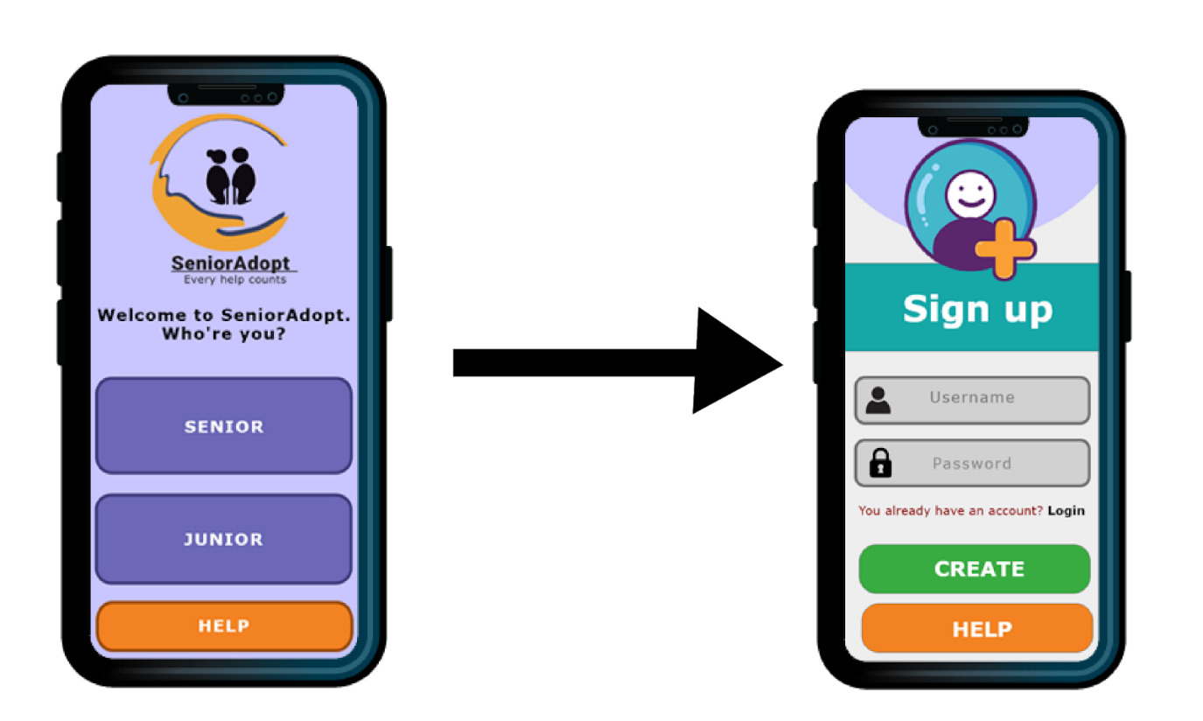

The purpose of this page is to determine what kind of role the user is, and to direct into the correct role and position. It's important to choose the one that applies the most and with one-click on the available options, it'll select the chosen role and it'll redirect to a Sign Up page.

Apply for both senior users and students. Here, they'll need to create their username and password. Username consists of alphabets and can combine with capital letter, numbers, but refrain from the use of space and comma. It's possible to use underscore and hashtag.

The password applies the same way as the username, the user will be able to fabricate their own unique password - to meet the criteria, the password length should contain at least 6-7 characters. The information is being stored in a database, sensitive information will be protected and encrypted with a secure password. When the user has completed the sign-up register and clicked on CREATE, the Welcoming Page will redirect the user to the Main Page.

After the account has been created, this is what the senior will see. Also, when the app is being relaunched, this is the page the senior will see. If a user already has an account, then, this will be the first page the user will see when launching/activating the app. Logging in will redirect the user to the MAIN PAGE.

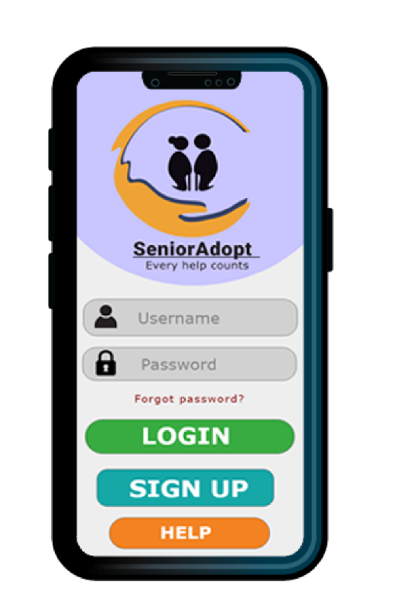 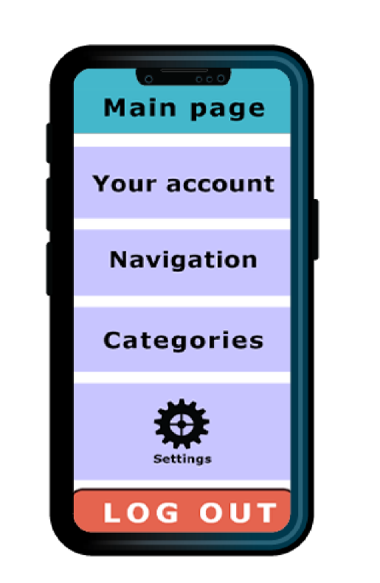

*START PAGE* *MAIN PAGE*

For the Start Page of the app before logging into the main page. We wanted the layout to contain less distraction as possible considering this interface is suitable for the seniors.

The logo will remain on top and is clickable, and it will take the user to the main page. The login button features a large font size, together with the Register button. They have been customized so that they are large enough to see. We wanted to create a simple clean interface, so this one we believe will be easy for the seniors to use.

For the help page, we think it’s important to include the emergency numbers, so they should always be available just in case something’s happening, whether it’ll be accidents or robbery, just to mention a few. We want to give the app a bit of diversion so the app can be used to call for emergency incidents as well.

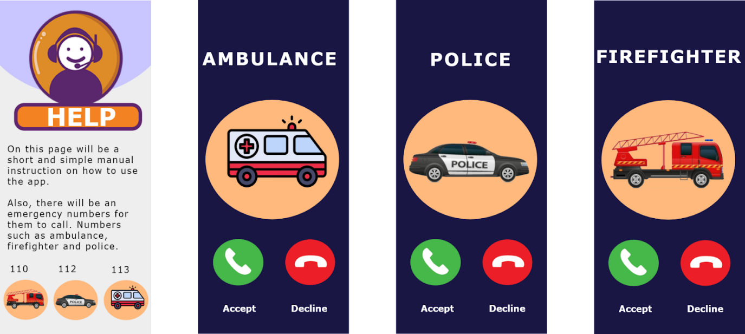  
  
For the navigation menus for the senior, they can check for the junior candidates’ profiles, check notifications and start booking a junior. The notification will let the senior know how many notifications they have received, like the example pictured underneath, there are four notifications visible.

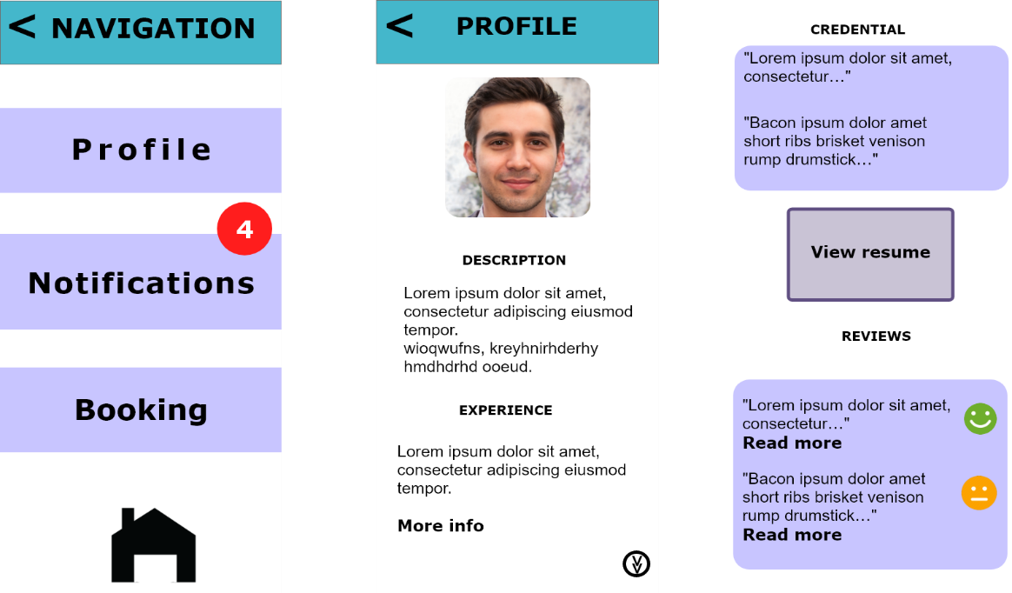

The notifications have their own page dedicated to the notification alert. Here the senior will be able to view the messages they’ve received; this can be from booking confirmations, messages between the senior and junior. The notification alert regarding the update of the app will be appearing only when it’s about time to update the new version - and it will be visible in the Notifications page.

For the profile there will be a database containing profiles of the junior candidates, here the seniors can read more about the junior candidates, view the credentials, resume, view the recommendation etc. providing so much information will help the seniors build trust and learn more about the suitable candidate.

Pictured underneath, the settings appear almost in the similar style as the smartphone options, however, this setting page will appear for both senior and junior, it’s a common setting page which will not be much different from each other. The setting of the app will give the user the option to toggle Dark Mode, change password, edit profile, and be able to turn on and off the notification alert (turning it off will put the notification on mute).

Language option gives the senior the language preference they wish to use, there is an arrow pointing aside, this indicates there’s more options for the language. The Delete my account appears in a red color to show the danger and if not careful, the account will be completely deleted and also the stored data will be permanently deleted, unless chosen to keep the data stored in the app for future use if the user decides to return.

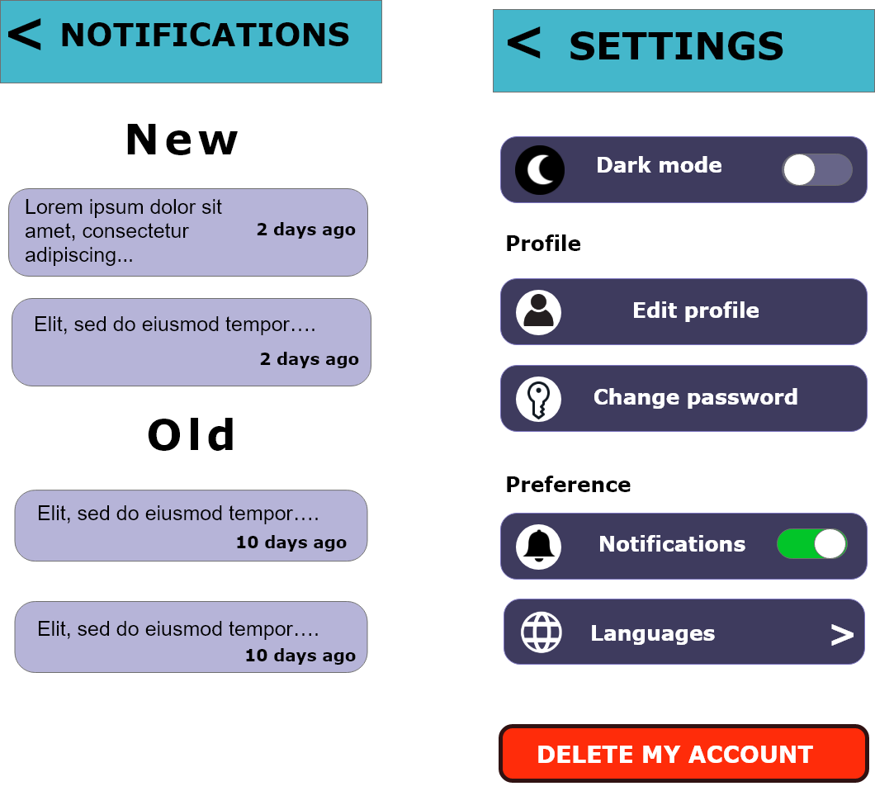 Senior interface: Notifications and Settings

As for the Categories, the seniors will have an opportunity to choose the service they wish to do. For Social service, the tasks will be related to the social activities, as seen below.

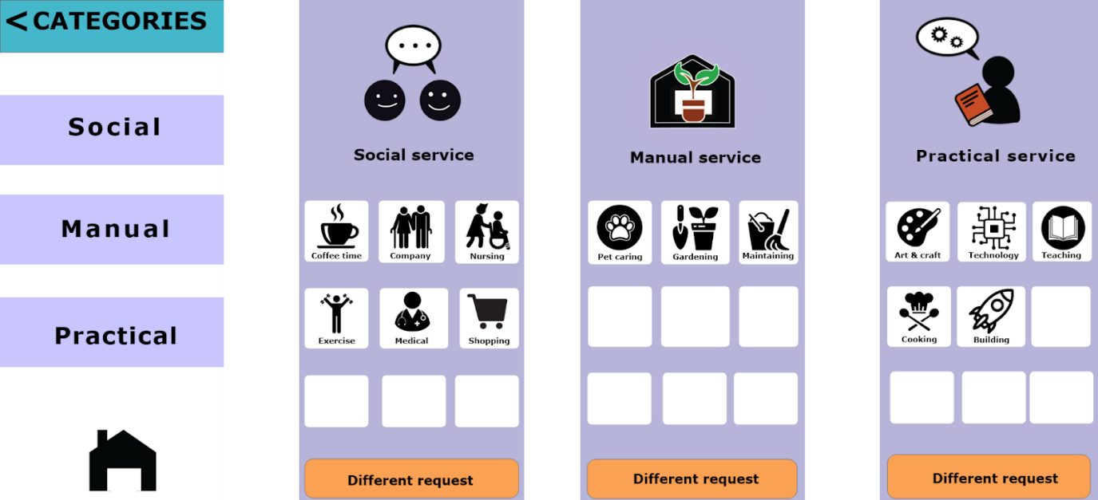

The Booking Page will contain the junior candidates’ databases, the senior can just click on the candidate’s box in order to book the candidate and be able to contact him/her via a video presentation. The green border around the video box indicates an ongoing call, there are two icons; one green receiver and red hang-up phone, similar design as the iPhone UI itself, just some inspiration.

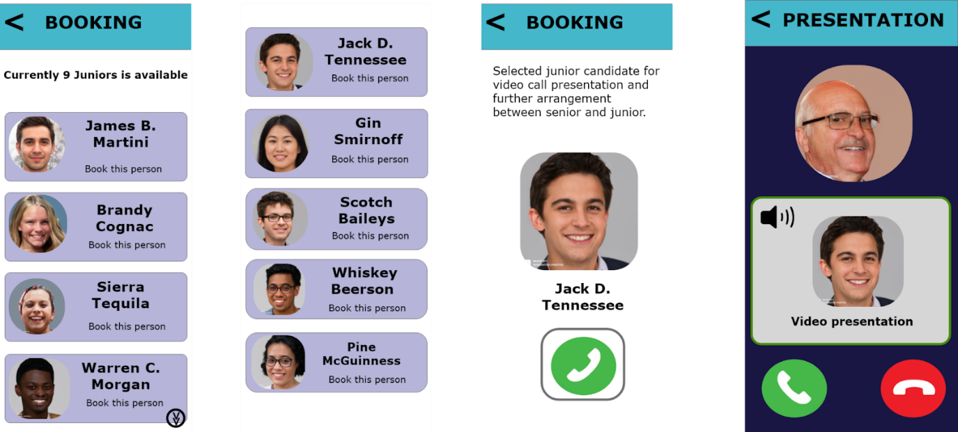

The Senior interface: Booking and Video presentation

Under is the account page for the senior. Here they’ll be able to not only upload and update a new ID photo of themselves, but also edit privacy settings such as change password, username and email.

Viewing the past booking history of the junior candidates, update or edit the details, adding some interests just to match with the junior candidate’s skills and passions. The log out button will just be logging off the account and take the senior to the start page of the app.

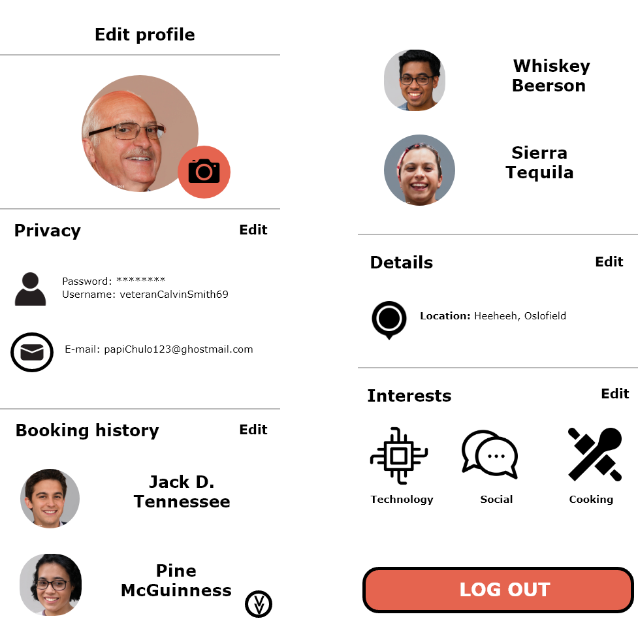

Pictured underneath is the Junior’s start page, slightly different from the Senior’s. The only thing that’s different is the login button and the colour itself, and there is no emergency help button. The design of the page is merely different, the only change is the bottom where there’s a small decor just for design purpose.

The first time entering the app, this is what the first time page will look like, it applies both to senior and junior. So, basically, this will be the page they will see only once and won’t be seeing it again after the sign up has been completed.



App front Sign up page

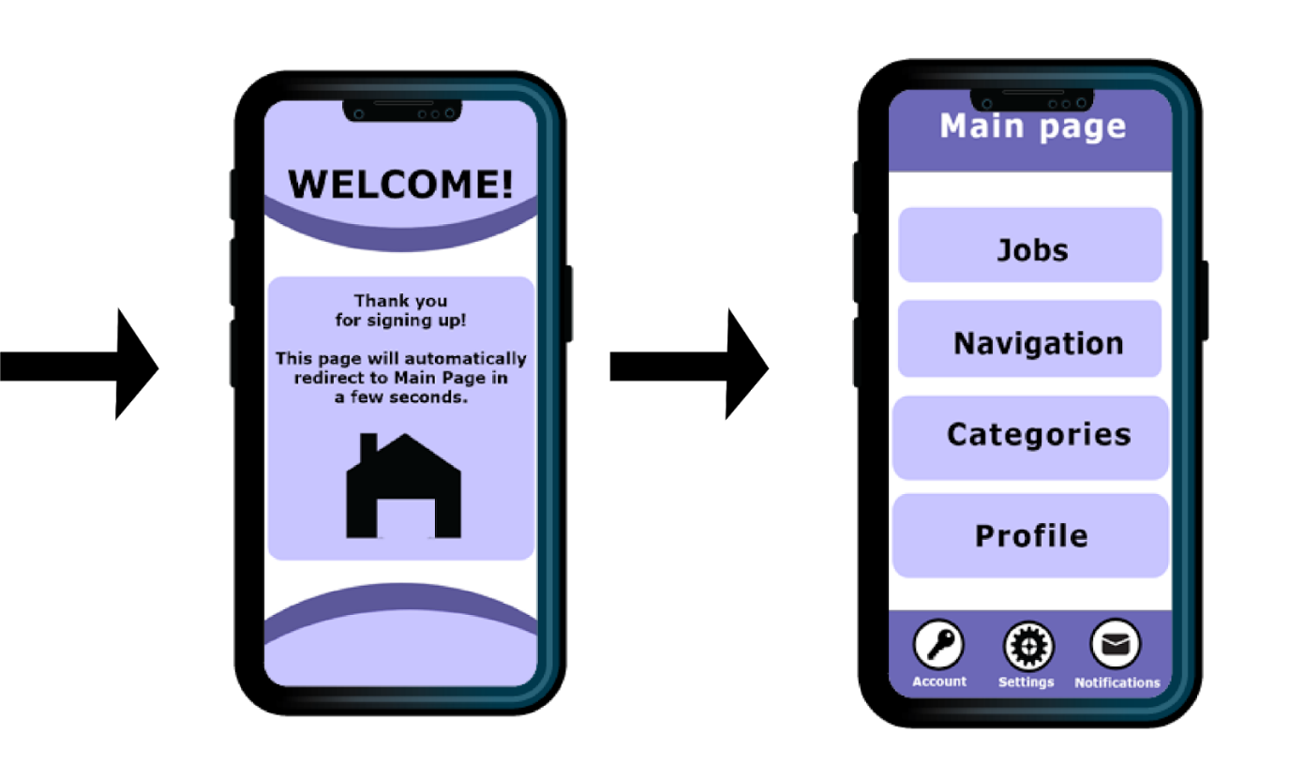

Welcome page Main page

The Main Page for the junior may have a slightly smaller change, there is now “Jobs” option visible, the design layout is also much different from the senior interface design. The junior now has Settings, Account and Notifications as a menu option visible at the bottom (this will remain at the bottom of the interface).

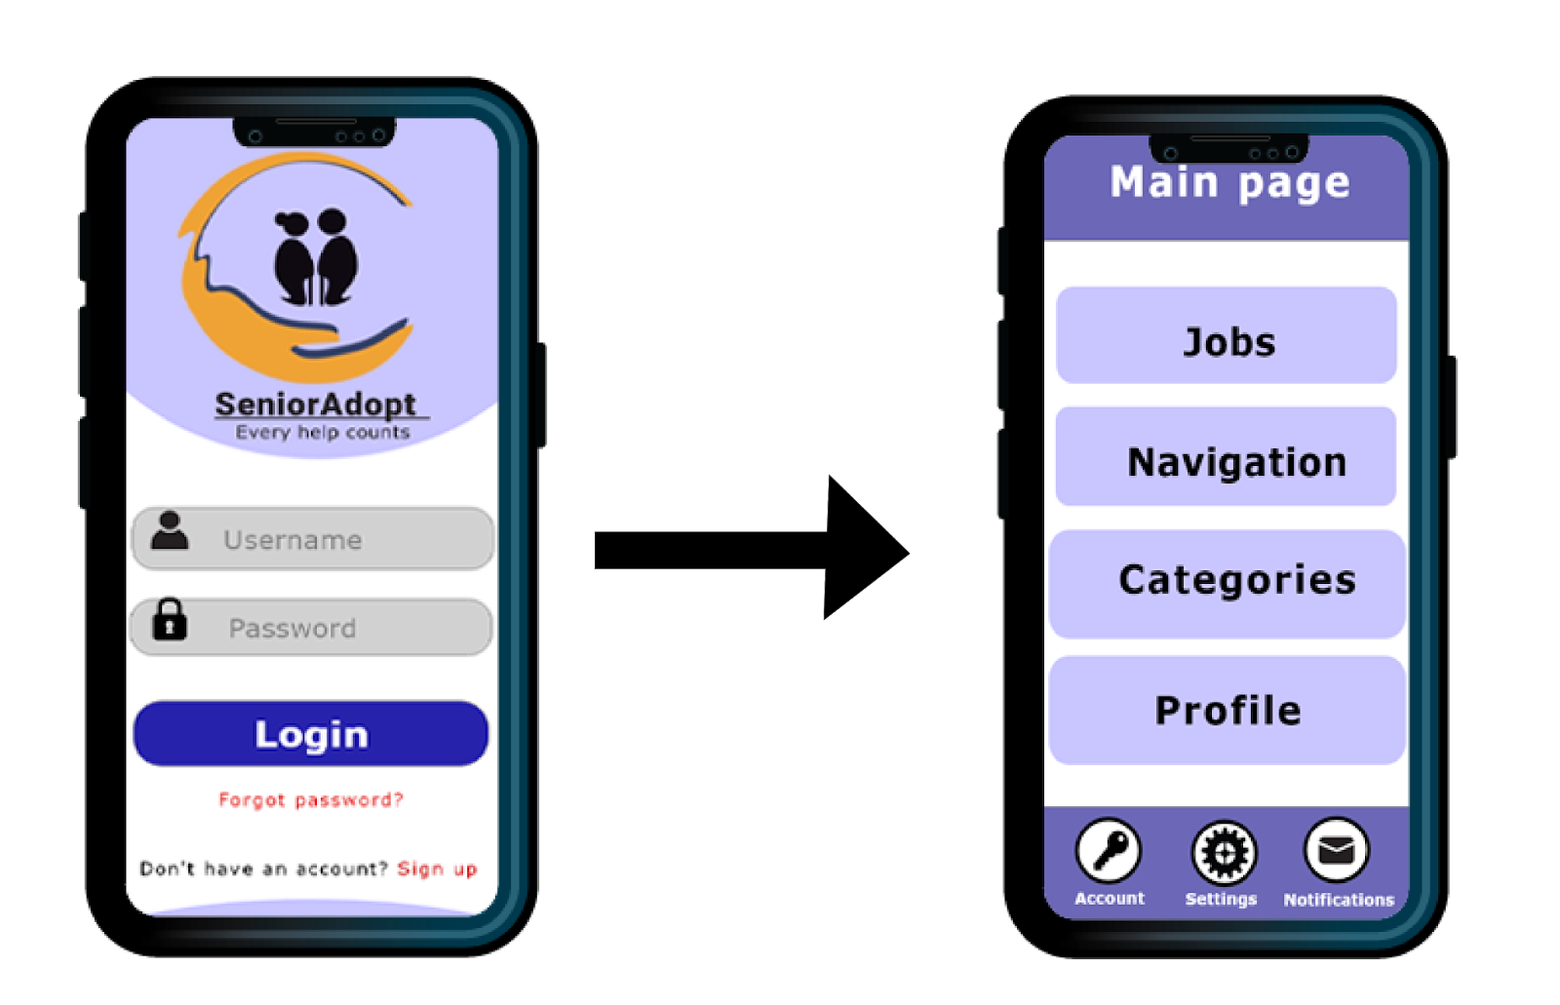

Start page Main Page

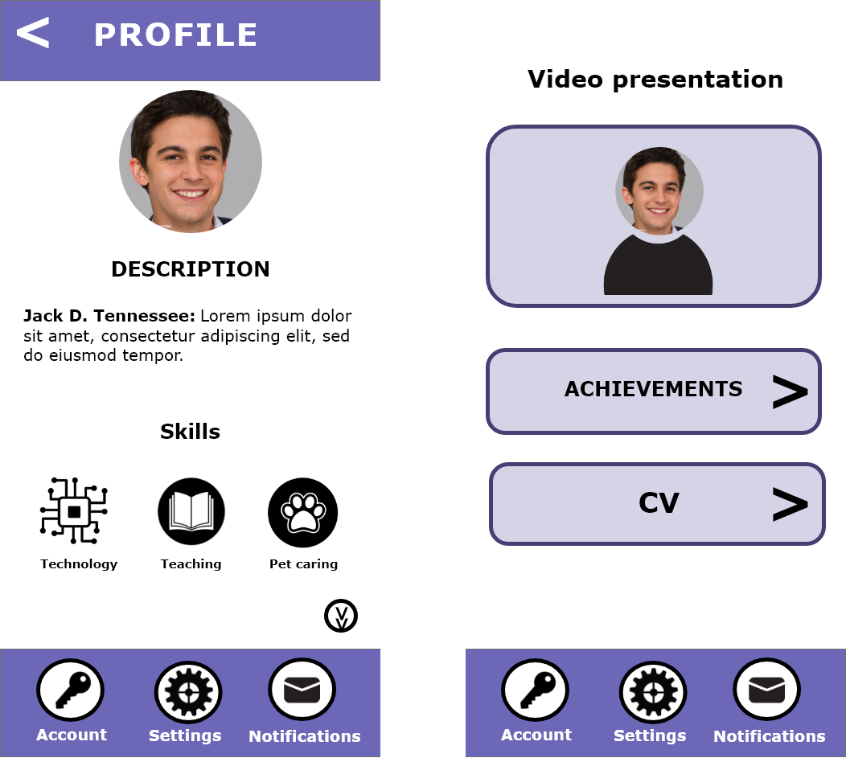

A profile page for the juniors, the Skills is where the student is specialised in and also interested in. It’ll be matching with the elderly’s need or interest to book. As seen in the Senior’s profile, it’s easy to see and match with the skills and the needs.

The page will contain video presentations, student’s achievements and CV. And a short introduction at the description area with a presentation video to give more detailed info.

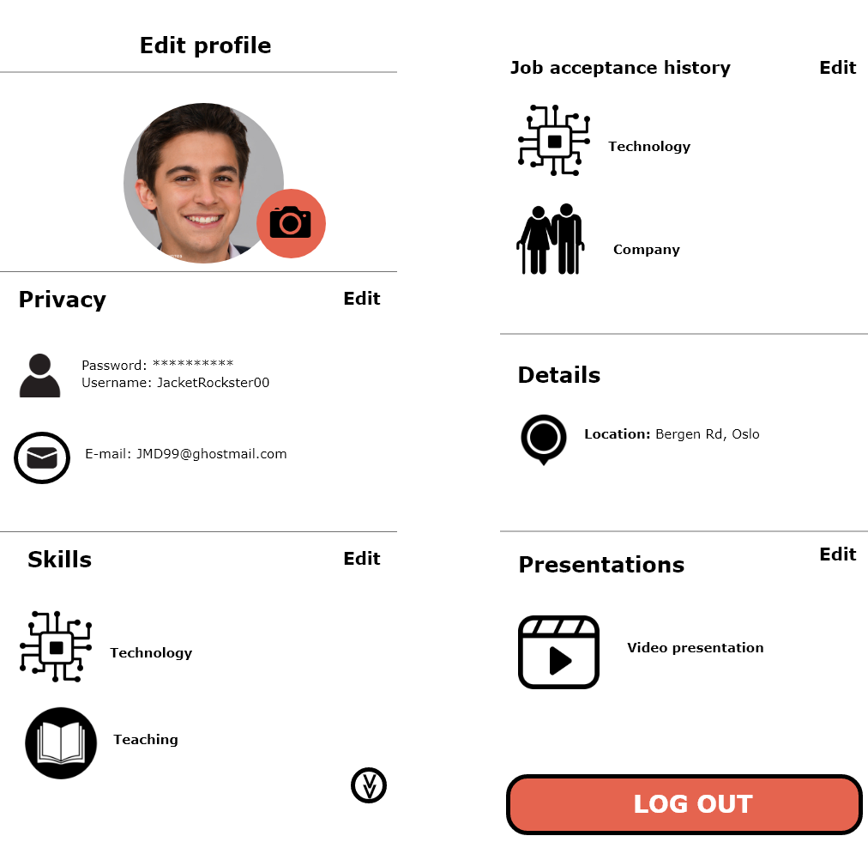

Edit profile is similar to the senior’s, however, the difference I have added is the skills, job acceptance history and the presentations. For the Skills, this indicates the interests and skills the junior is interested and specialized in. While the Job Acceptance History shows the job request this candidate has done. So, therefore, Jack D. Tennessee has accepted a job within Practical Service and Social Service in the previous time ago.

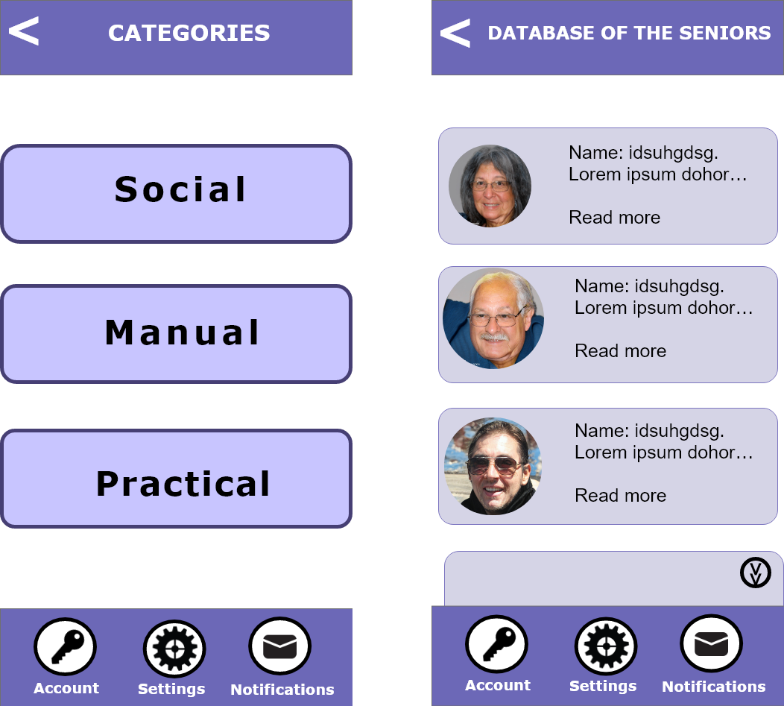

Categories Database of the seniors

## PART 5: THE FUTURE

### Future development

In the future, the application would be possible to expand to a global market. The reasoning for this is that there will always be senior citizens, and younger people available. Based on statistics by Eurostat (Eurostat, 2021) and the Norwegian Statistic Central Bureau (SSB, 2017), young people are struggling to find jobs all around the EU, and it seems a lasting issue for the future.

As of now, SeniorAdopt is a mobile and tablet app only, but it’s entirely possible that desktop and online versions will be developed in the future if this is highly requested by the users of the app, but for now, the focus will be to update and maintain the current app solution.

As the years go by, the userbase will change and will consist of users well-versed in the world of technology, and it will be essential that SeniorAdopt adapt with the times in order to survive as an app, like adding social media integration, add-ons, more categories added, expanding geographical area, develop desktop and online versions, and so forth.

Only the sky is the limit when it comes to SeniorAdopt.

## REFERENCES

Altinn (n.d.). Støtteordninger. Retrieved from <https://www.altinn.no/starte-og-drive/stotteordninger/?filter=d1-14235,d2-14223,d2-14222,d2-14221>

Alscher, D. (2019, 10. June) Color Contrast: For the sake of aesthetic and accessibility. G2. Retrieved from <https://www.g2.com/articles/color-contrast>

Centers for Disease Control and Prevention (2021). Loneliness and social isolation linked to serious health conditions.Retrieved from: <https://www.cdc.gov/aging/publications/features/lonely-older-adults.html>

Cybulski, M., Krajewska-Kułak, E., Sowa, P., Orzechowska, M., Damme-Ostapowicz, K. V, Rozwadowska, E., & Guzowski, A. (2013, October). Elderly Peoples’ Perception of Young People – A Preliminary Study. Iranian Journal of Public Health, 42(10), 1099. Retrieved from <https://www.ncbi.nlm.nih.gov/pmc/articles/PMC4436537/>

Eurostat (2021, September). Youth unemployment - Statistics Explained. Retrieved from <https://ec.europa.eu/eurostat/statistics-explained/index.php?title=Youth_unemployment>

Fjørtoft, T. O. (2017, 6. June) Unge og høyt utdannede er flinkest foran PC-en. Statistisk sentralbyrå. Retrieved from: <https://www.ssb.no/teknologi-og-innovasjon/artikler-og-publikasjoner/unge-og-hoyt-utdannede-er-flinkest-foran-pc-en>

Foreningen SeniorSmart (2021) SeniorSmart for økt aktivitet, livsglede og mindre ensomhet. Retrieved from [https://www.seniorsmart.no](https://www.seniorsmart.no/)

Kenton, W. (2003).Bootstrapping Definition*.* Investopedia. Retrieved from <https://www.investopedia.com/terms/b/bootstrapping.asp#:~:text=Bootstrapping%20describes%20a%20situation%20in,revenues%20of%20the%20new%20company>.

Lotame (2019, 11. March) What is market segmentation? Retrieved from <https://www.lotame.com/what-is-market-segmentation/>

NFkino. (n.d.). Seniorkino | NFkino*.* Retrieved from <https://www.nfkino.no/seniorkino?city=oslo#concepts:d89e89f679113e2de969ec51a9668395>

No Isolation (n.d.). Why do many seniors have trouble using technology? Retrieved from: <https://www.noisolation.com/research/why-do-many-seniors-have-trouble-using-technology>

Norsk Katapult. (n.d.). Norsk katapult - Gjør veien fra ide til marked kortere.Retrieved from <https://norskkatapult.no/>

OBOS (2021). Nabohjelp –den snille naboen. Retrieved from <https://nye.obos.no/nabohjelp/>

Om Enhetsregisteret - Brønnøysundregistrene. (2020). Brønnøysundregistrene. <https://www.brreg.no/om-oss/oppgavene-vare/alle-registrene-vare/om-enhetsregisteret/?nocache=1638396778692>

Pettersen, M. (2021, 26. August) Trenden er brutt – flere unge utenfor i 2020*.* Statistisk sentralbyrå. <https://www.ssb.no/arbeid-og-lonn/sysselsetting/statistikk/tilknytning-til-arbeid-utdanning-og-velferdsordninger/artikler/trenden-er-brutt--flere-unge-utenfor-i-2020>

Smith, A. (2014). Attitudes, Impacts, and Barriers to Adoption. Washington DC. USA. Pew Research Centre. Retrieved from: <https://www.pewresearch.org/internet/2014/04/03/attitudes-impacts-and-barriers-to-adoption/>

Stiftelsen Dam (2017). WeCare -et digitalt omsorgsverktøy. Retrieved from <https://dam.no/prosjekter/wecare-et-digitalt-omsorgsverktoy/>

Ulvund, M. J. (2020, 20. November). Mange gamle kan ingenting om data, vi må få lavterskel kurs. *Stavanger Aftenblad*. Retrieved from <https://www.aftenbladet.no/meninger/debatt/i/bnzO8e/mange-gamle-kan-ingenting-om-data-vi-maa-faa-lavterskel-kurs>

U.S. Small Business Administration (n.d.). Fund Your Business. Retrieved from <https://www.sba.gov/business-guide/plan-your-business/fund-your-business>

World Health Organization. (2021, October 4). Ageing and health. Retrieved from <https://www.who.int/news-room/fact-sheets/detail/ageing-and-health>

Yeung, C. (2019, 29. August). Social media usage statistics by age: Marketing to adults aged 50+. Synthesio. Retrieved from <https://www.synthesio.com/blog/social-media-usage-statistics-by-age/>

## APPENDICES

1. The Value Proposition of SeniorAdopt.

